Overview

The purpose of this project is to create a database using SQLite and then have the application convert the animal name to the ID of the animal as well as add a GPS location to the application.

### PROCESSING LOGIC

The process used in the application was to use onclick to the gather information that is stored in the editText and saved that to a variable. The variable then would be called during an the process of loading up the database. As well as using a join method to join the two databases together. As well as using a foreign key in the database. When the button called Location is clicked it will display the current location.

### DATA (INPUT/OUTPUT)

The input came from the user entering in text and clicking buttons, and the output was messages being displayed that the database has been updated with the information they have sent. The output will be the display of the latitude and longitude.

### COMPONENTS (SOURCE CODE NAMES, CLASSES, METHODS)

The text boxes were used to gather data from the user. Then the view content button enabled the ability to view the database.

### TESTING

##### Example 1: Location

##### Steps to test

##### 

##### Click location to have the message displayed.

##### Expected result:

##### It will display the current GPS location.

Example Scenario 2 – starting the application

Steps to test

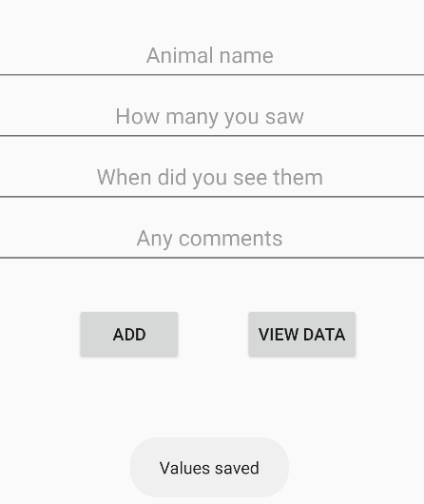

Click add:

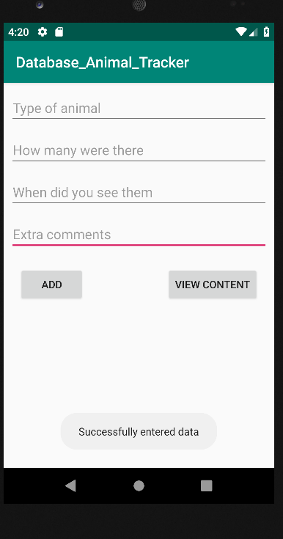

Expected reaction

The message will appear if data is entered correctly

Example 3: view content

Steps to test

Click view content to have database show.

Expected result:

Will be for database to be displayed

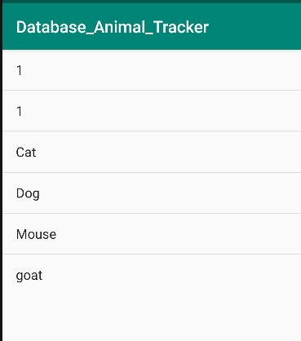

Example 4: Edit or Delete data

Steps to test

Click on one of the data Entries to be able to either save a new version of that name or delete it.

Expected result:

After reloading database the change will have taken place.